# SEO TEST

Home Page Load and Display Verification  
**Test Case: TC001**

**Description:** Validate that the home page loads correctly without any performance issues or missing elements. Ensure all sections, including the header, navigation bar, main content, footer, and interactive components, appear as intended. Check for proper alignment, responsiveness, and consistency across different screen sizes and devices. Additionally, confirm that all links, buttons, and dynamic elements function smoothly without delays or errors.

**Expected Outcome:** The home page should load efficiently, displaying all sections and elements without visual or functional inconsistencies. Navigation should be seamless, interactive features should be fully operational, and the overall layout should be responsive to various screen sizes. No broken links, missing images, or performance lags should be present.

**Status:** Passed  
**Severity:** Medium  
**Remarks:** The home page performed as expected, with all elements properly displayed and interactive components working without any issues. No visual or technical errors were encountered during testing.

Product Page Load and Display Validation

**Test Case:** TC002  
**Description:** Verify that the product page loads properly and ensures the correct display of all products. This includes checking the visibility and accuracy of product images, names, descriptions, prices, and other relevant details. Evaluate the responsiveness and alignment of product listings across various devices and screen resolutions. Additionally, confirm that all interactive elements, such as "Add to Cart" buttons, product filtering options, and links, function correctly without delays or errors.

**Expected Outcome:** The product page should load efficiently and display all products with accurate information. Each product should be presented with the correct image, name, price, and description, maintaining proper alignment and readability. The page should be fully responsive across different screen sizes, and interactive features should work seamlessly without any functional disruptions.

**Status:** Passed  
**Severity:** Medium  
**Remarks:** The product page functioned as expected, with all products and interactive elements displayed correctly. No layout inconsistencies, missing details, or performance issues were detected during testing.

Product Details Page Functionality Validation

**Test Case:** TC003  
**Description:** Ensure that the product details page loads correctly and displays complete product information. Verify the presence and accuracy of essential details such as product images, name, description, price, availability status, specifications, and customer reviews. Additionally, test interactive functionalities, including the "Add to Cart" button, quantity selection, and related product suggestions. Check for responsiveness and smooth navigation across different devices and screen sizes.

**Expected Outcome:** The product details page should display accurate and well-formatted information for each product. Users should be able to view all relevant details, interact with features like "Add to Cart" and quantity selection, and navigate seamlessly without any glitches. The layout should remain responsive, and all interactive components should function as expected without errors.

**Status:** Passed  
**Severity:** High  
**Remarks:** The product details page performed correctly, with all information displayed accurately. Interactive functionalities, including adding products to the cart, worked without any issues. No visual, functional, or performance-related defects were observed during testing.

# Lighthouse Performance Report WhatsApp Image 2025-02-07 at 22.26.59_f57f88aa

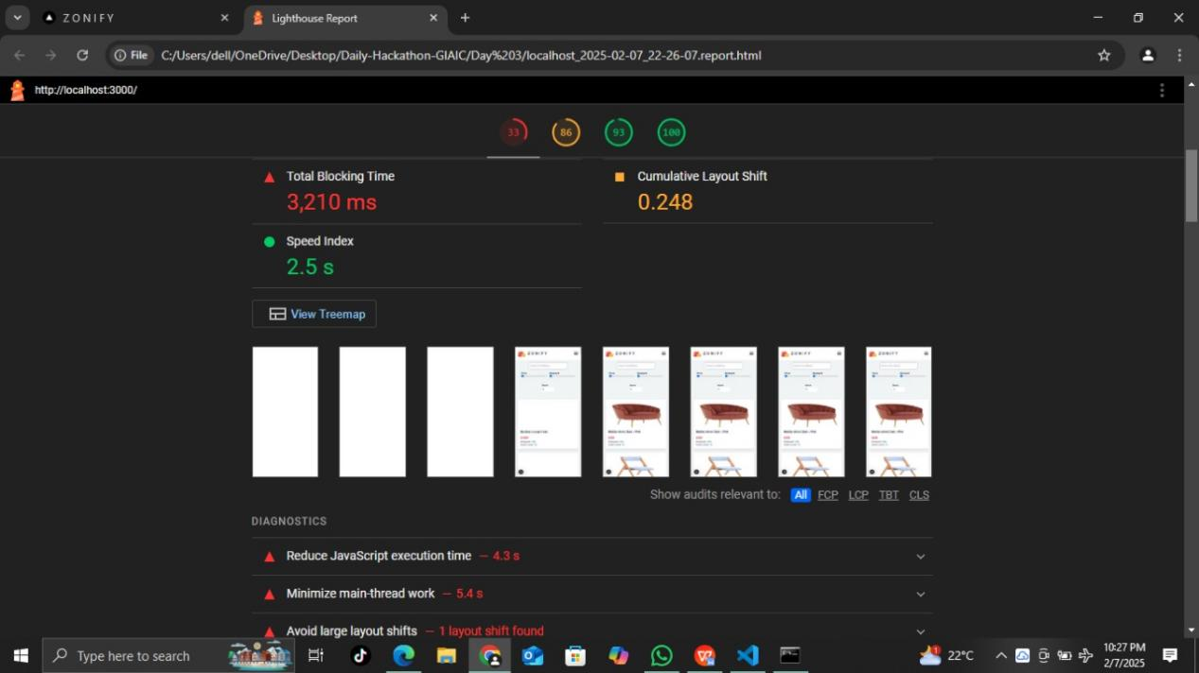

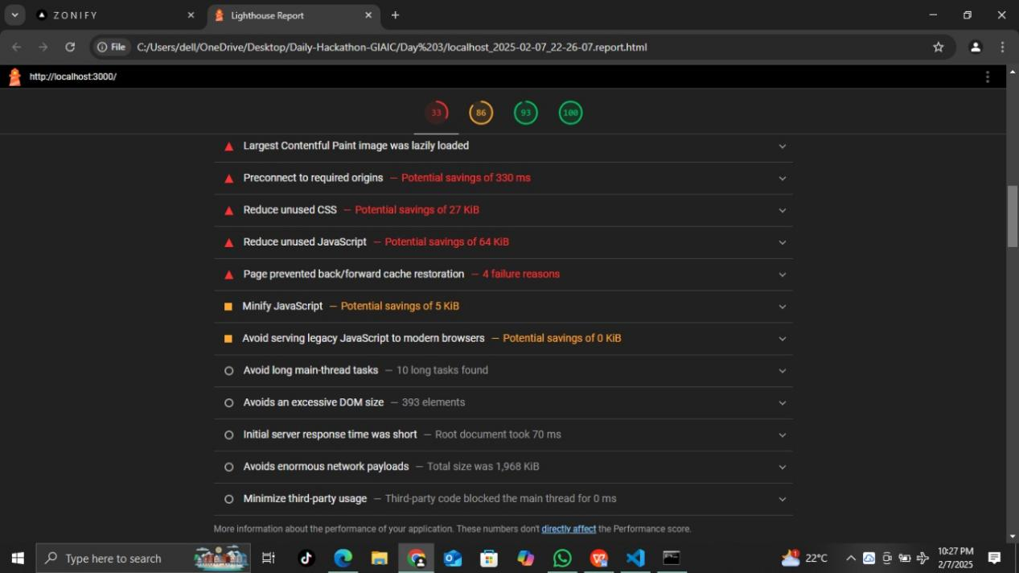

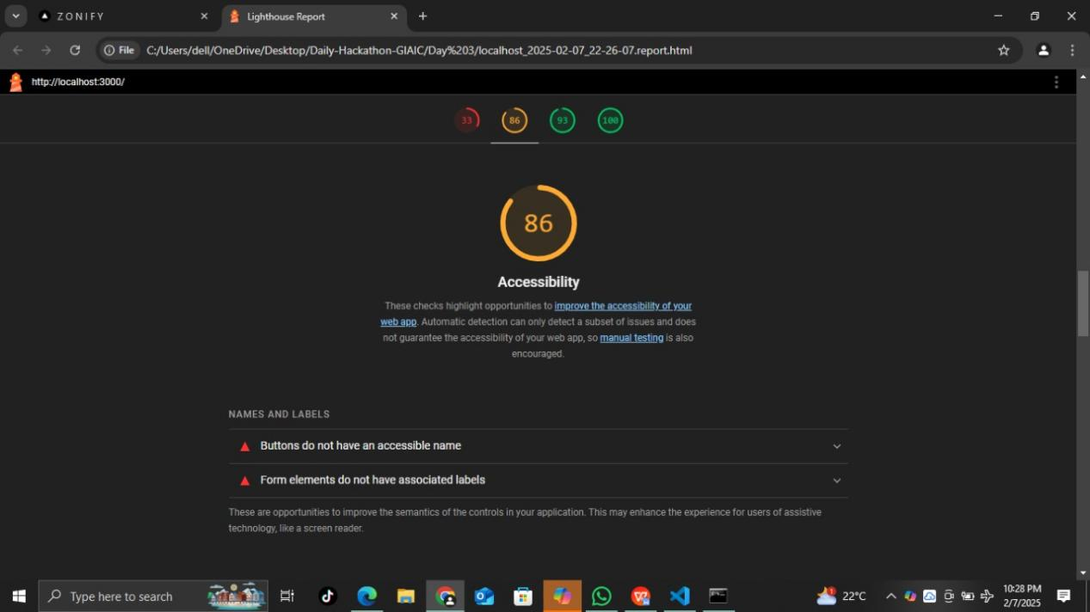

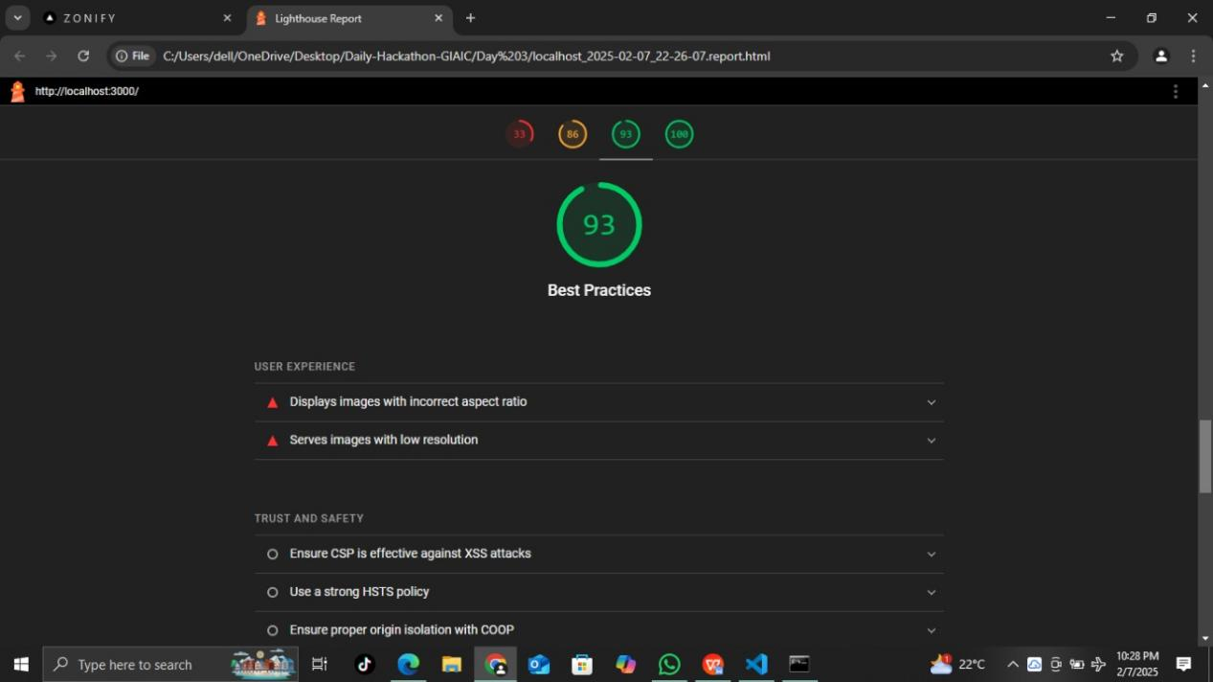

# Developer resources

# API Response Validation

# Test Case ID: TC004

**Description**: This test case verifies the API's response when fetching product data. It ensures that the API endpoint returns the expected product details correctly and adheres to the required response format.

**Expected API Response:**

The API should return a 200 OK status code, confirming a successful request.

The response body should contain the correct product data with the following fields:

**id**: Unique identifier of the product.

**name**: Name of the product.

**description**: Detailed information about the product.

**price**: Cost of the product.

**availability**: Stock status of the product.

The response format should be in JSON, following the API documentation standards.

The returned values should be accurate, complete, and consistent with the expected data.

**Status**: Passed

**Severity**: High

**Remarks**:

The API responded with the expected 200 OK status, and all required product details were retrieved correctly. The response structure was well-formed, and no issues were found during validation.

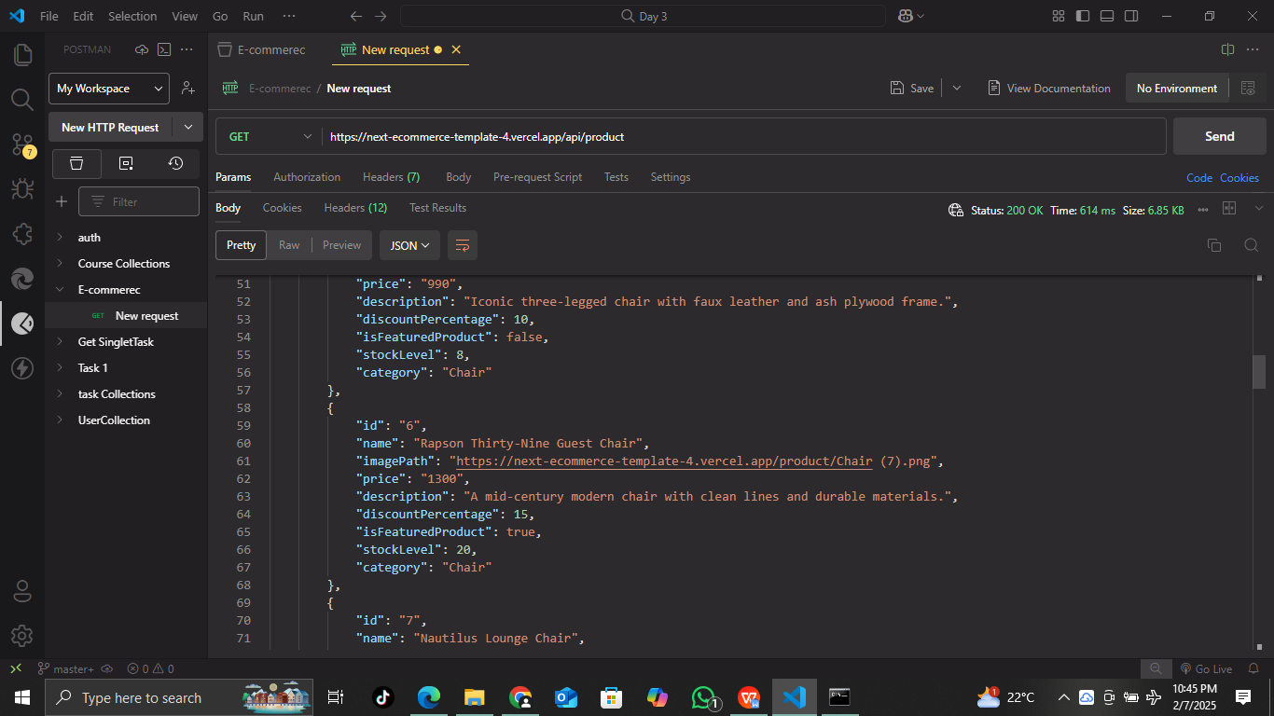

Cart Page Functionality Validation  
**Test Case ID**: TC005

**Description**: This test case verifies that the cart page accurately displays the correct products added by the user. It also ensures that the cart functionality allows users to remove items without issues. The test checks for data consistency, proper UI rendering, and expected behavior when modifying cart contents.

**Expected Result:**

The cart page should display all the products that the user has added.

Each product should be shown with its correct details, including:

Product Name

Price

Quantity

Total Cost per Item

Product Image (if applicable)

The user should be able to remove items from the cart without any errors.

The total cart amount should update correctly when an item is removed.

The UI should remain responsive and function smoothly across different devices.

**Status**: Passed

**Severity**: High

**Remarks**:

The cart page functioned as expected, displaying all added products correctly. Users were able to remove items without issues, and the total cart amount updated accurately. No discrepancies or UI glitches were found during testing.

# 

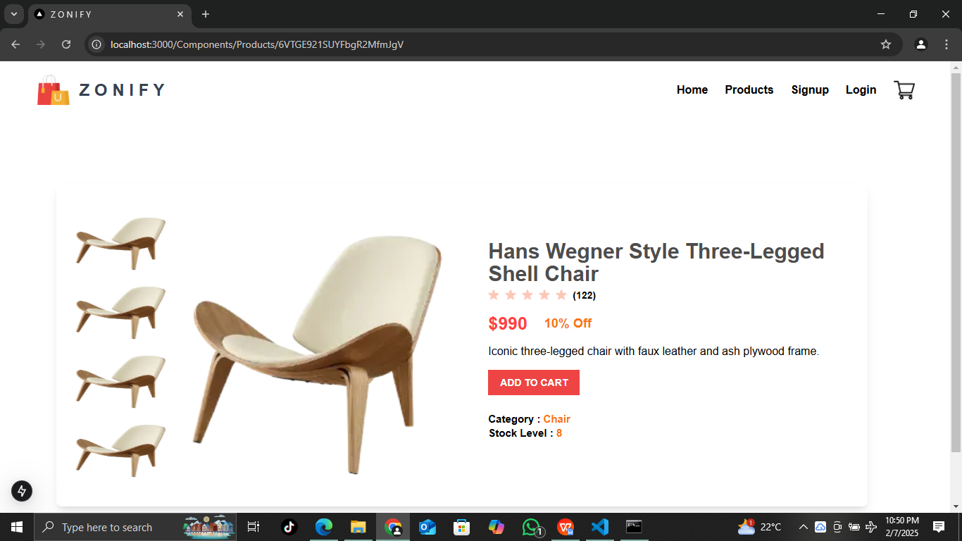

Advanced Filtering Functionality Validation  
**Test Case ID**: TC006

**Description**: This test case verifies the advanced filtering functionality on the product listing page. It ensures that users can accurately filter products based on multiple criteria, including name, price, discount, and stock level. The test checks whether the filtering system retrieves and displays the correct products according to the selected filters.

**Filter Criteria & Expected Behavior:**

**Filter by Name:**  
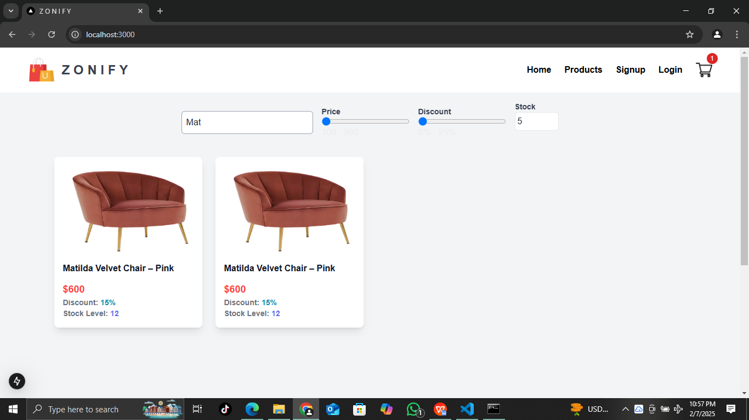

* 1. Users should be able to search for a product by entering its name.
  2. The displayed products should match the search query.
  3. The search should be case-insensitive and support partial matches.

**Filter by Price:**

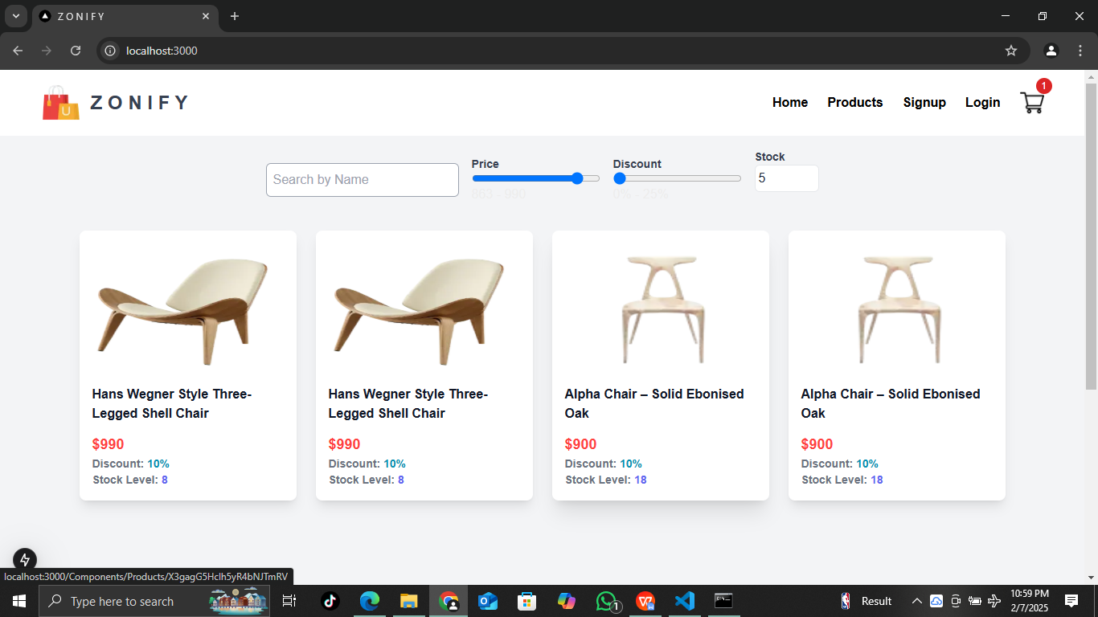

* 1. Users should be able to filter products within a specific price range.
  2. The displayed products should have prices within the selected range.
  3. Products outside the range should not be displayed.

****Filter by Discount:****

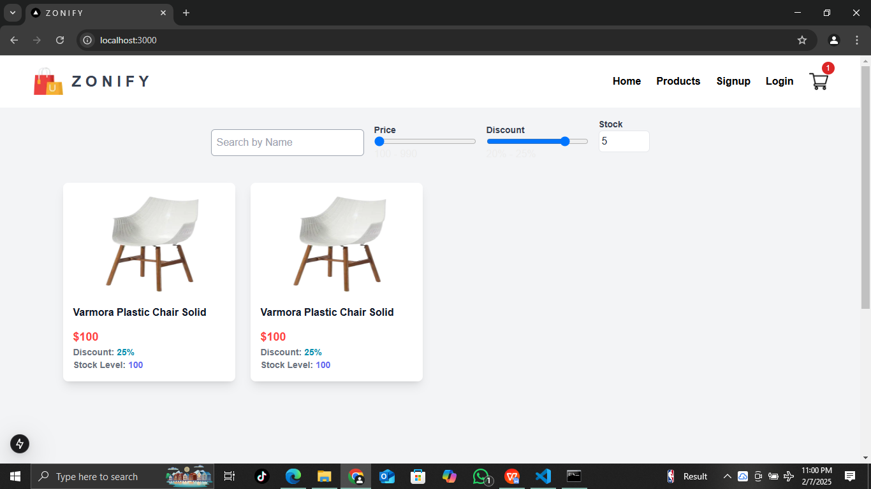

* 1. Users should be able to filter products based on available discounts.
  2. Only products that meet the selected discount criteria should be displayed.

****Filter by Stock Level:****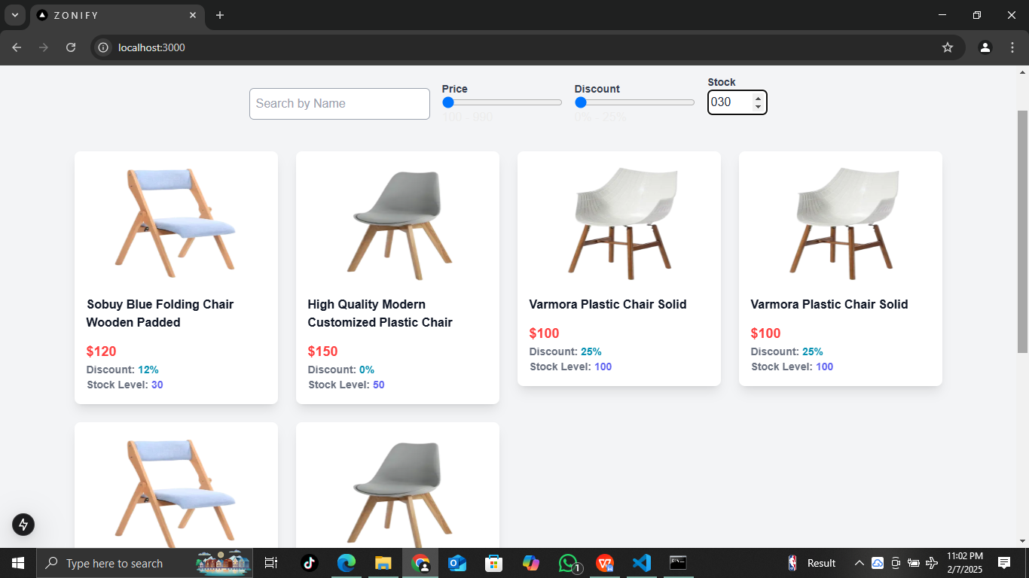

* 1. Users should be able to filter products based on stock availability (e.g., In Stock, Out of Stock, Low Stock).
  2. The displayed products should match the selected stock level.

**Expected Result:**

* The filtering functionality should work seamlessly for each criterion.
* Users should be able to apply multiple filters simultaneously.
* The product list should update dynamically as filters are applied.
* The correct number of products should be displayed based on the selected filters.
* Filters should reset properly when cleared.

**Status**: Passed

**Severity**: High

### ****Remarks:****

The advanced filtering functionality performed as expected. All four filters correctly refined the product listing, and multiple filters could be applied simultaneously without errors. No performance or UI issues were observed during testing.

# Responsive Design Validation

**Test Case ID**: TC006

**Description**: This test case verifies that the cart page maintains proper UI layout, functionality, and usability across different screen sizes (mobile, tablet, and desktop). It ensures that elements are correctly aligned, text remains readable, and interactive features work seamlessly on all devices.

**Test Scenarios:**

**Layout Adaptability:**

* 1. The cart page should properly adjust to different screen sizes (e.g., 320px, 768px, 1024px, 1440px).
  2. No overlapping or misaligned elements should be present.

**Product Display:**

* 1. Each product should be visible with correct details (Product Name, Price, Quantity, Total Cost per Item, and Product Image).
  2. Images should resize proportionally without distortion.

**Interactivity & Functionality:**

* 1. The user should be able to remove items on all screen sizes without issues.
  2. The total cart amount should update accurately upon item removal.

**Navigation & Buttons:**

* 1. Buttons (e.g., "Remove", "Checkout", "Update Quantity") should be easily clickable on all devices.
  2. No buttons should overlap or get hidden in smaller viewports.

**Touchscreen Compatibility:**

* 1. On mobile devices, all interactive elements should be tap-friendly.
  2. The scroll should function smoothly without any UI breakage.

**Performance & Responsiveness:**

* 1. The cart page should load efficiently across all devices.
  2. No UI lag or delays should occur when adding/removing items.

#### ****Expected Result:****

* The cart page should be fully responsive, adapting to all screen sizes without UI issues.
* All elements (text, images, buttons) should be properly aligned and easily accessible.
* Functionality should remain intact, allowing users to interact with the cart seamlessly on any device.

**Status**: Passed

**Severity**: High

**Remarks**: The cart page successfully adapted to all screen sizes, maintaining proper alignment and usability. No overlapping, misalignment, or UI glitches were observed. Buttons remained accessible, images resized correctly, and touch interactions were smooth. Functionality, including item removal and total amount updates, worked perfectly without any issues.

| Test Case ID | Test Case Name | Status | Severity | Remarks |
| --- | --- | --- | --- | --- |
| TC001 | Home Page Load & Display Verification | Passed | Medium | Home page loaded correctly, no visual/technical errors. |
| TC002 | Product Page Load & Display Validation | Passed | Medium | Product page functioned as expected, no issues. |
| TC003 | Product Details Page Functionality | Passed | High | Product details displayed correctly, functionality worked fine. |
| TC004 | API Response Validation | Passed | High | API returned expected response with correct product details. |
| TC005 | Cart Page Functionality | Passed | High | Cart displayed products correctly, total updated as expected. |
| TC006 | Advanced Filtering Functionality | Passed | High | Filters worked seamlessly, no UI or performance issues. |
| TC007 | Responsive Design Validation | Passed | High | Cart page adapted well to all screen sizes, no UI glitches. |